JIRA Quick Start Guide
You may use CITnet's JIRA issues for:
- Any support question on the software or the procedure (i.e. Pilot-phase),
- bugs in VECTO-tools, or
- general ideas for discussion,
To submit a new issue, click the "Create" button at the top-bar:
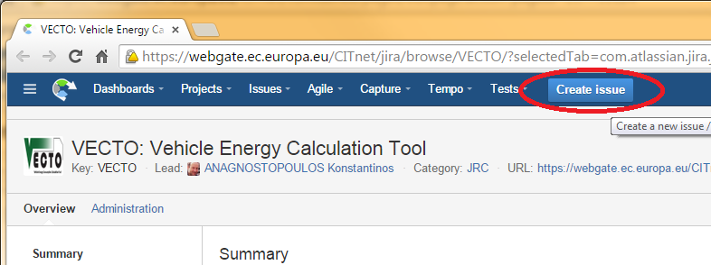
Fields are needed (marked with those required when creating an issue):
- Issue-Id: Created after you save the issue, and it has the form "VECTO-13". It is appended at the beginning of every thread-title,and it is used as a reference throughout external-systems and/or emails.
- Issue-type: Required to select one of the following when creating an issue:
  - BUG (If unsure, select this)
  - Improvement
  - New feature
  - Support - questions about CITnet, user-permissions, administrative
  - Task - non-software related activities (i.e. PilotPhase)
- Summary: A descriptive phrase giving a clear explanation the issue, to be used as Title.
- Description: Detailed description of the issue; rich text formatting maybe used.
- Components: One of: Simulator, CSE, Infrastructure, Administrative, ... It is used to select automatically an Assignee.

JIRA Workflow
The following workflow elements are used to communicate the progress on an issue:
- Status: It may be: DRAFT, OPENED, IN PROGRESS, ..., RESOLVED, INVALID, CLOSED, and others, depending on its Issue-type. Users change it to signify work-progress. For instance, Issues are considered completed when they are Closed.
- Comments: A series of 'Comments', that describe the job performed for accomplishing the bug and ANY user feedback. These correspond to the replies in the mailing-list analogy.
- Files and Screenshots
- The 'People' are different fields specifying users to be notified with emails for all changes and comments on the issue.
- Assignee: The person currently responsible to respond or to make some job for the issue to proceed. After an assignee performs its tasks, he should re-assign the task to whoever should next take charge of the issue. If unsure, assign to the component-owner or to some manager.
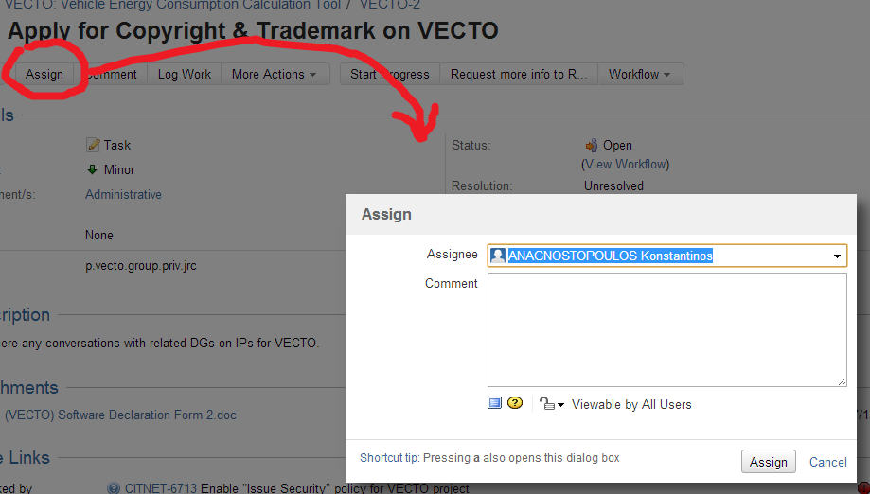
- Reporter: The user that has initially created the issue.
- Watchers: Users who are to receive emails on every change. You can add yourself as a Watcher to any issue.
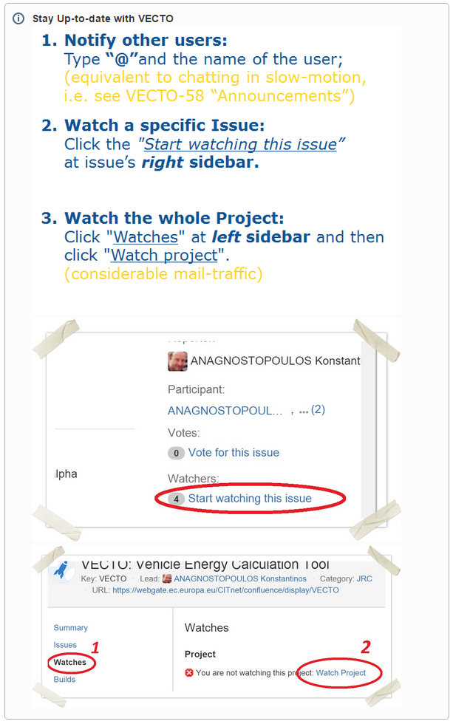

For more information visit the VECTO wiki:
https://webgate.ec.europa.eu/CITnet/confluence/display/VECTO/JIRA+Overview

